**FLOOD MONITORING AND EARLY WARING SYSTEM**

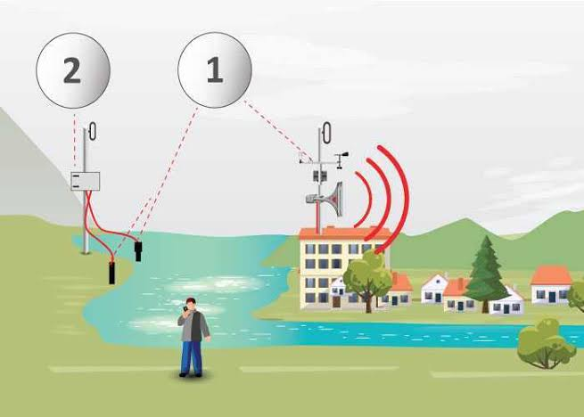

**SUBMITTED BY,**

JAYASRI k - 812921106019

SWETHA R - 812921106036

DIVAGAR R - 81292106010

HARIHARAN S - 812921106015

Table of contents

* Abstract
* Objective
* Introduction
* Problem definition
* Block diagram
* Explanation
* Desing thinking
* Data collection
* Components
* Hardware stepup
* Program
* Output
* Conclusion

ABSTRACT

* The purpose of this project is to sense the water level in river beds and check if they are in normal condition. If they reach beyond the limit, then it alerts people through LED signals and buzzer sound. Also it alerts people through Sms and Emails alerts when the water level reaches beyond the limit.
* Flood monitoring involves the systematic observation and analysis of water levels, precipitation, and related environmental parameters to assess and predict flood events This abstract explores various methods and technologies employed in flood monitoring, including remote sensing, sensor networks, and modeling techniques
* . The aim is to enhance early warning systems, improve disaster response, and mitigate the impacts of flooding on communities and infrastructure

OBJECTIVES

The objective of flood monitoring is to gather real-time data and information about current and potential flooding situations. This helps in:

**1. *Early Warning\***: Providing timely alerts to communities and authorities, allowing them to take preventive measures.

**2. *Risk Assessment**\*: Assessing the severity and potential impact of floods on affected areas.

**3. *Response Planning**\*: Allowing authorities to plan and allocate resources for evacuation, rescue, and relief efforts

**4. *Infrastructure Protection**\*: Protecting critical infrastructure like roads, bridges, and utilities from flood damage.

**5. *Environmental Impact**\*: Understanding the ecological consequences of floods and implementing measures to mitigate them.

**6. *Policy and Planning*:** Informing urban planning and development decisions to reduce vulnerability to floods.

**7. *Data for Research and Analysis**\*: Providing valuable data for scientific research, climate modeling, and flood risk assessment.

**INTRODUCTION**

In the recent days, Many countries are facing of several social issues in aged population, healthcare, disaster reduction/prevention, safety, security, etc. the natural disasters occur in many areas and many people loss their lifeprogress of India towards smart cities and digitalization is noticeable. India’s historicvulnerability cannot be overstate. Around 57% land is vulnerable to earthquakes. Of these, 12% is vulnerable to severe earthquakes, 68% land is vulnerable to drought, 12% land is vulnerable to floods, 8% land is vulnerable to cyclones, and many cities in India are also vulnerable to chemical, industrial and man-made disastersIn the recent years, on 30 July 2014 manypeople lost their lives because of Malin landslides disaster due to the heavy rain in Malinvillage of pune district in Maharashtra, India. Malin village receiving the heavy rain on 29th July 2014 and the date of 30th July landslide will occurred due to heavy rainfall. This issue will observed because of deforestation and many other several reasons. There are many more disasters will occurred but the solution is to be implemented the internet of things techniques to reduce the lossesand makes an early warning system This system utilizes the Internet-of-Things (IoT) technologies to helps in social infrastructures to opens a new door for innovative solutions to prevent the losses from natural disasters like floods, forest fire, earthquake, spark etc. and the most important thing is to we save our life and also saves theanimals life we firstly focuses on flood alert system .Internet based sensor networks have recently gaining theattention Sensors are connected to the Internet and the information from the sensors is gathered at a server. When Particular region is equipped with sensor devices, microcontroller, and various application become a self-protecting and self-monitoring that environment is the smart environment. Sensors sensor information transmission and monitor the data which will Flood Monitoring and Early Warning System (FMEWS) is a comprehensive infrastructure designed to detect, monitor, and provide timely alerts about potential or ongoing flood events. Its primary objective is to mitigate the impact of floods on communitIYT

PROBLEM DEFINITION

A flood monitoring program is a structured initiative aimed at systematically observing, collecting, and analyzing data related to flood events. It typically involves the deployment of various sensors, gauges, and monitoring systems in flood-prone areas to track water levels, weather conditions, and other relevant parameters. The program's objective is to provide timely and accurate information about potential or ongoing floods, enabling authorities to make informed decisions for disaster preparedness, response, and mitigation efforts. Additionally, flood monitoring programs may incorporate data analysis and modeling techniques to predict and assess flood risks in vulnerable region

BLOCK DIAGRAM

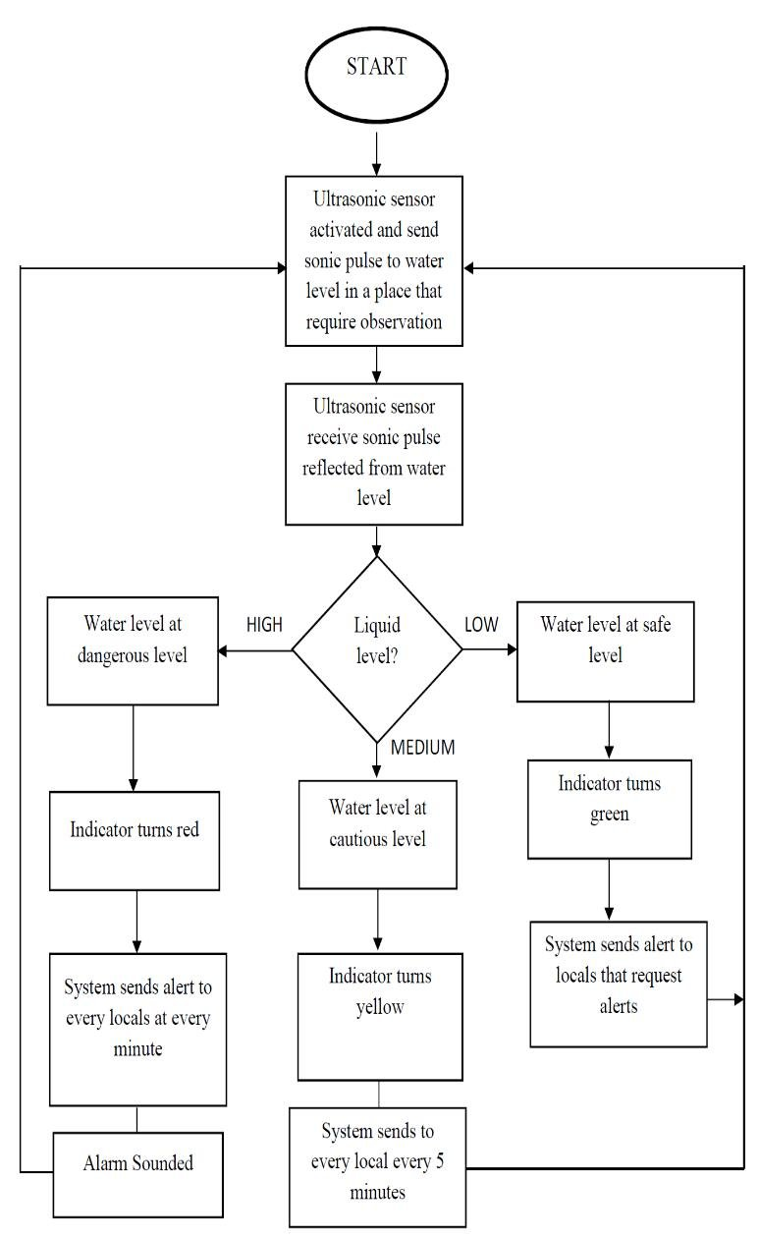

BLOCK DIAGRAM EXPLANATION

1. **Sensors**: These are strategically placed devices that monitor various parameters such as water levels, rainfall intensity, and river flow rates. They provide real-time data essential for flood prediction and monitoring.

**2. Data Processing and AnalysiS**: Raw data from sensors is processed and analyzed to determine trends, anomalies, and potential flood risks. This component employs algorithms and models to interpret the data and make accurate flood predictions.

**3. Communication Infrastructure**: FMEWS relies on robust communication networks to transmit data between sensors, data processing units, and the central monitoring system. This can include wired or wireless networks, satellite communication, or a combination of these.

**4. Central Monitoring and Decision Support System**: This is the core component of the FMEWS. It integrates data from various sources, conducts real-time analysis, and utilizes historical information to make informed decisions about flood conditions. It can also provide recommendations for response actions.

**5. User Interface**: A user-friendly interface allows stakeholders, including government agencies, emergency responders, and the public, to access critical information. This can be in the form of dashboards, mobile applications, or web platforms displaying real-time data and alerts.

**6. Alerting Mechanisms**: The system is equipped with various alerting mechanisms to notify individuals and organizations at risk of impending floods. These alerts can be delivered via SMS, emails, sirens, or automated phone calls.

**7. Community Engagement and Preparedness**: FMEWS often includes public awareness campaigns and community engagement initiatives to educate people about flood risks and preparedness measures. This helps enhance the effectiveness of early warning systems.

**8. Historical Data Storage and Analysis**: Storing and analyzing historical data is crucial for improving flood forecasting models, understanding long-term trends, and refining response strategies.

DESING THINKING

Design thinking is a human-centered approach to problem-solving that involves empathy, ideation, and prototyping. Here's how you might apply it to designing a flood monitoring and early warning system:

1. **\*Empathize*:**

- Understand the needs and concerns of the community at risk of floods. Conduct interviews, surveys, and engage with stakeholders to gather insights.

- Consider the cultural, social, and economic aspects that may influence the effectiveness and acceptance of the system.

**2. *Define*:**

- Clearly articulate the problem you're solving. For example, it could be providing timely and accurate flood warnings to vulnerable communities.

*Ideate*:

- Brainstorm possible solutions. Consider both high-tech and low-tech options. This could range from sensor-based systems to community-based early warning networks.

- Encourage creativity and diverse perspectives within your team.

**4. *Prototype*:**

- Create a small-scale version of your solution. This could be a mock-up, a simplified working model, or a digital simulation.

- Test the prototype with a focus group or in a controlled environment to gather feedback.

**5. *Test*:**

- Put your prototype in a real-world scenario (simulated or controlled) to see how it performs. Evaluate its effectiveness, accuracy, and user-frieden Collect feedback from users and stakeholders.

**6. *Iterate*:**

- Based on the feedback received, refine and improve your prototype. This might involve making adjustments to the technology, user interface, or communication methods.

**7. *Implement*:**

- Develop the final version of the flood monitoring and early warning system based on the refined prototype.

- Consider scalability, sustainability, and integration with existing infrastructure.

**8.** **\*Evaluate*:**

- Once implemented, continuously monitor the system's performance and gather user feedback. Make necessary adjustments to improve its effectiveness.

Remember, throughout the process, involve the end-users and stakeholders. Their input is crucial for creating a system that truly addresses their needs and concerns. Also, consider factors like accessibility, affordability, and reliability to ensure the system is inclusive and serves

DATA COLLECTION

There are few places on Earth where people need not be concerned about flooding. Any place where rain falls is vulnerable, although rain is not the only impetus for flood.

A flood occurswhen water overflows or inundates land that's normally dry. This can happen in a multitude of ways. Most common is when rivers or streams overflow their banks. Excessive rain, a ruptured dam or levee, rapid ice melting in the mountains, or even an unfortunately placed beaver dam can overwhelm a river and send it spreading over the adjacent land, called a floodplain.

Coastal flooding occurs when a large storm or tsunami causes the sea to surge inland. According to reports from the World Meteorological Organization (2009), approximately 70% of all disasters occurring in the world are related to hydro-meteorological events. Among the disasters, flooding probably is one of the most severe disasters affecting the people across the globe.

India is the worst flood affected country in the world after Bangladesh and accounts for onefifth of global death count due to floods. Nearly 75 percent of the total Indian rainfall is concentrated over a short monsoon season of four months (June-September).

As a result, the rivers witness a heavy discharge during these months, leading to widespread floods. About 40 million hectares of land in the country is liable to floods according to National Flood Commission, and an average of 18.6 million hectares of land is affected annually.

COMPONENTS

* Hardware Specifications
* .Raspberry Pi 3
* .Wifi Module
* 4LCD Display
* Water Sensor
* Rain Drop Sensor
* Resistors
* Capacitors
* Transistors
* .Cables and Connectors
* .Diodes
* PCB and Breadboards
* LED
* Transformer/Adapter
* Push Buttons
* Switch
* IC
* IC Sockets
* Software Specifications
* Linux
* Programming language:python

**Arduino:**

Arduino is a single-board microcontroller that is widely used to create various types of digital devices, block diagram shown In figure You can control and interact with various electronics components such as sensors, actuators and much more. It has its own fixed RAM and stores data quickly memory and EEPROM

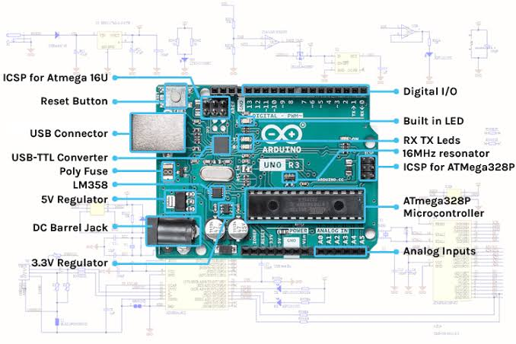

**2 . Buzzer:**

Buzzer or Beeper is an audio signing tool, which can be mechanical, electromechanical, or piezoelectric. Buzzer and beepers is widely used in include alarm devices, timers, and user input verification such as mouse clicks or key

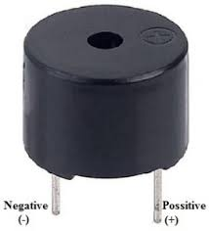

**3.Water Level Sensor:**

A water level sensor is a sensor that relays information back to a control panel to indicate whether a body of water has a high or low water level. The water level sensor employs a simple mechanism to detect and indicate the water level in an overhead tank or any other water container according to Electronic Hub.

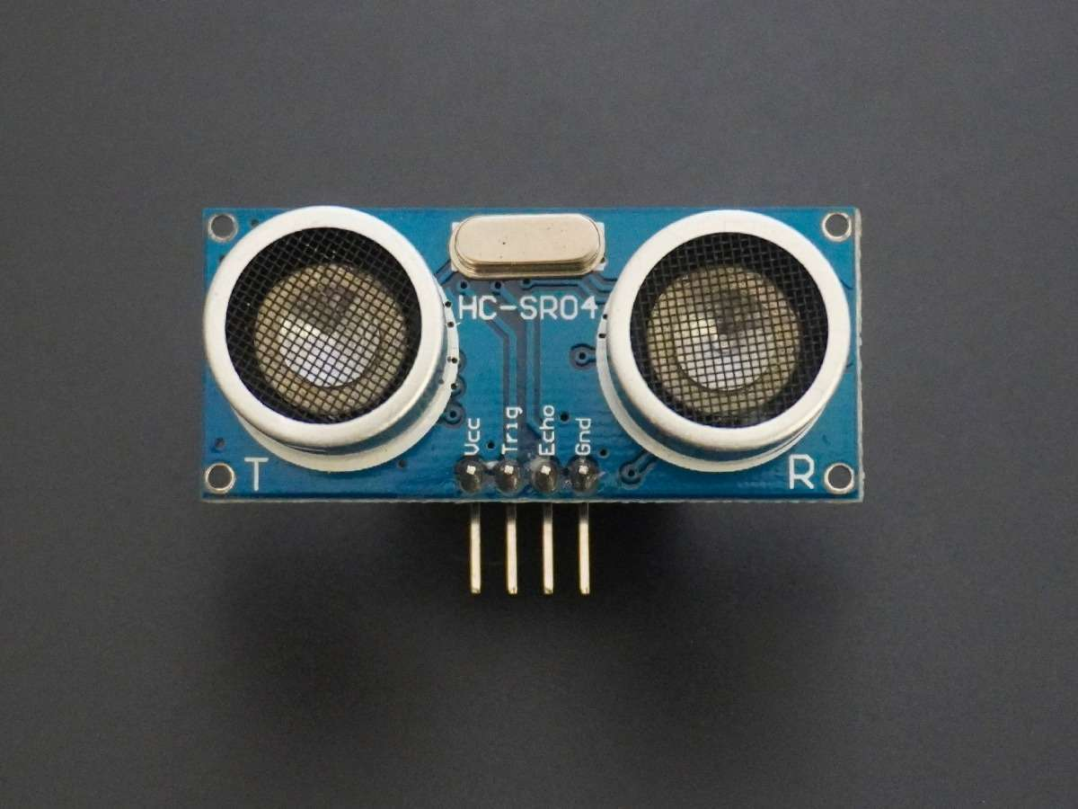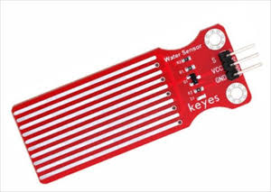

Things used in this project

**Hardware components** -

1.Bolt-IoT wifi module

2.Arduino uno

3.Breadboard- 400 tie points

4.5mm LED:(Green, Red, Orange) and Buzzer

516×2 LCD Display

6.LM35 Temperature Sensor

7.HC-SR04 Ultrasonic Sensor

8.Some Jumper Wires

* .Male to Female Jumper Wires- 15 pcs
* .Male to Male Jumper Wires- 10 pcs
* .Female to Female Jumper Wires- 5 pcs

9.9v Battery and Snap Connector

10.USB Cable Type B

**Software components** -

1.Arduino IDE

2.Python 3.7 IDLE

3.Bolt IoT Cloud

4.Bolt IoT Android App

5.Twillo SMS Messaging API

6.Mailgun EMAIL Messaging

7.APISoftware component

HARDWARE SETUP

**Step 1: Connecting LED’S**

**For Green LED:**

* VCC of Green Colour LED to Digital Pin ‘10’ of the Arduino.
* GND of Green Colour LED to the GND of Arduino.

**For Orange LED:**

* VCC of Orange Colour LED to Digital Pin ‘11’ of the Arduino.
* GND of Orange Colour LED to the GND of Arduino

.

**For Red LED:**

* VCC of Red Colour LED to Digital Pin ‘12’ of the Arduino.
* GND of Red Colour LED to the GND of Arduin

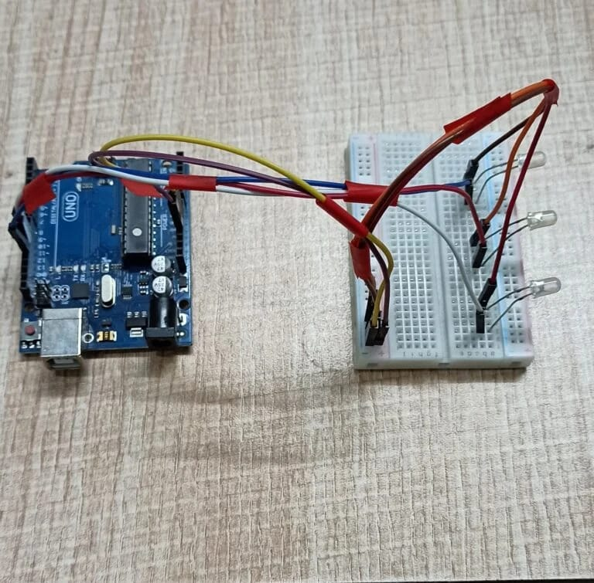

**STEP 2:Connetin Buzzer**

* VCC of Buzzer to Digital Pin ‘13’ of the Arduino.
* GND of Buzzer to the GND of Arduio.

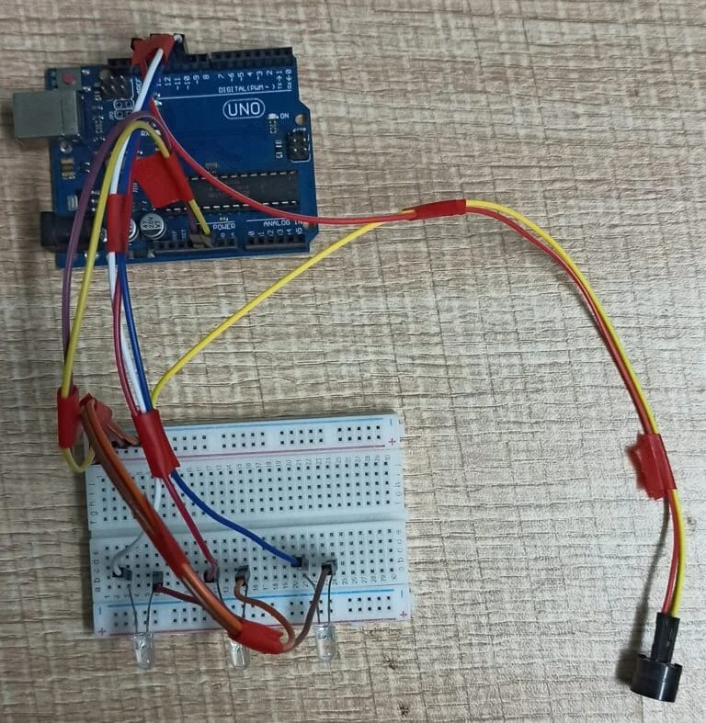

**Step 3: Connecting HC-SR04 Ultrasonic Sensor**

* VCC of Ultrasonic Sensor to 5v of Arduino.
* GND of Ultrasonic Sensor to GND of Arduino.
* Echo of Ultrasonic Sensor to Digital Pin ‘8’ of Arduino.
* Trig of Ultrasonic Sensor to Digital Pin ‘9’ of Arduino.

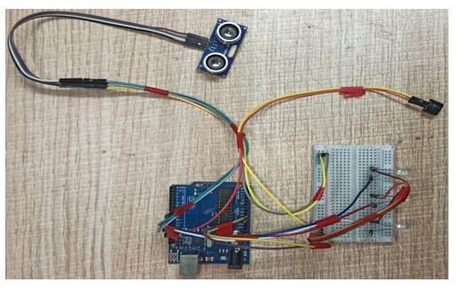

**Step3: Connecting Bolt WiFi Module:**

* 5v of Bolt WiFi Module to 5v of Arduino.
* GND of Bolt WiFi Module to GND of Arduino.
* TX of Bolt WiFi Module to RX of Arduino.
* RX of Bolt WiFi Module to TX of Arduino.

**Step 6: Connecting LM35 Temperature Sensor**

* VCC of LM35 to 5v of Bolt WiFi Module.
* Output Pin of LM35 to Pin ‘A0’ of Bolt WiFi Module.
* GND of LM35 to GND of Bolt WiFi Module

**Step 7:Connecting 16×2 LCD Display**

* Pin 1,3,5,16 of 16×2 LCD to GND of Arduino.
* Pin 2,15 of 16×2 LCD to 5v of Arduino.
* Pin 4 of 16×2 LCD to Digital Pin ‘2’ of Arduino.
* Pin 6 of 16×2 LCD to Digital Pin ‘3’ of Arduino.
* Pin 11 of 16×2 LCD to Digital Pin ‘4’ of Arduino.
* Pin 12 of 16×2 LCD to Digital Pin ‘5’ of Arduino.
* Pin 13 of 16×2 LCD to Digital Pin ‘6’ of Arduino.
* Pin 14 of 16×2 LCD to Digital Pin ‘7’ of Arduino



After doing the hardware onnection put all the hardware components in one box.

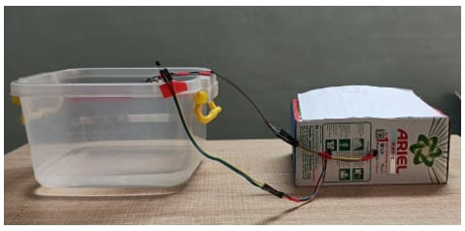

Also attach LM35 temperature sensors on the container

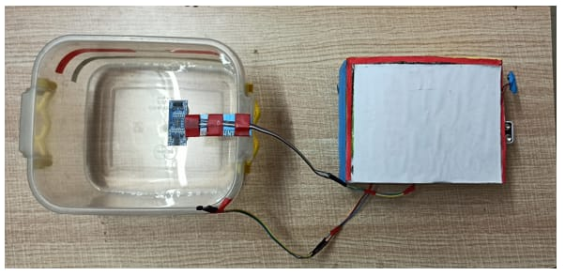

Also attach the ultrasonic sensor on the to of the container

AREA AFFECTED POPOLATION AFFECTED AND HUMAN LIVES LOTS

A COMPARATIVE ANALYSIS:

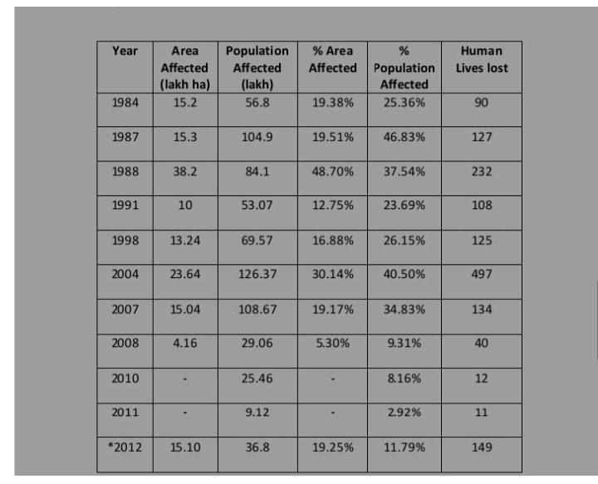

PROGRAM

LiquidCrystal lcd(2,3,4,5,6,7);

float t = 0;

float dist = 0;

void setup()

{

lcd.begin(16,2);

pinMode(18,OUTPUT); //trigger pin

pinMode(19,INPUT); //echo pin

pinMode(20,OUTPUT); //buzzer

lcd.setCursor(0,1);

lcd.print(" Water Level Detector");

delay(2000);

}

void loop()

{

lcd.clear();

digitalWrite(20,LOW);

digitalWrite(18,LOW);

delayMicroseconds(2);

digitalWrite(18,HIGH);

delayMicroseconds(10);

digitalWrite(18,LOW);

delayMicroseconds(2);

t=pulseIn(19,HIGH);

dist=t*340/20000;

lcd.clear();

lcd.setCursor(0,1);

lcd.print("Distance : ");

lcd.print(dist/100);

lcd.print(" m");

delay(1000);

if(dist<40)

{

digitalWrite(20,HIGH);

lcd.clear();

lcd.setCursor(0,1);

lcd.print("Water level is rising. Kindly evacuate");

delay(2000);

}

else

{

digitalWrite(20,LOW);

delay(2000);

}

}

PROGRAM SCHREEN SHORT

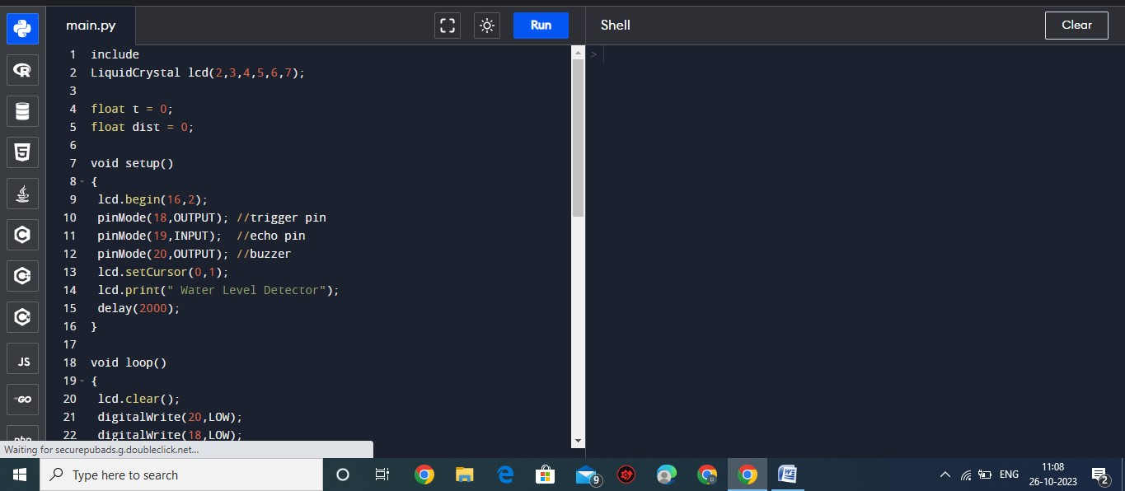

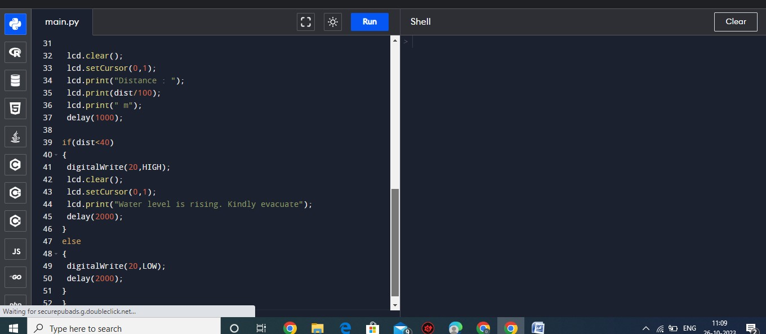

OUTPUT :

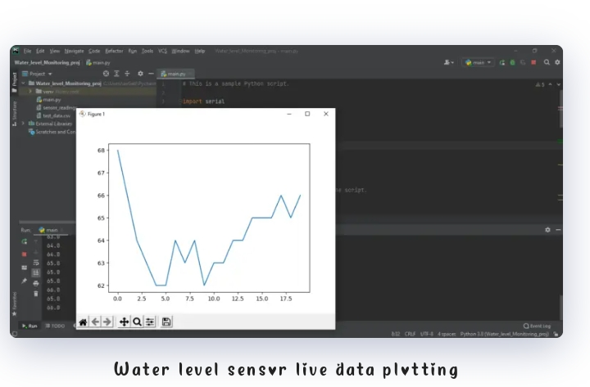

CONCLUSION

An IOT based Flood disaster management system has been proposed adapt new techniques, could reduce the chances of losses of human lives as well as damage to large-scale infrastructures due to both naturaland human-made disasters. According to this project we can implement inexpensive wireless sensor network components to detect floods, spark, forest fire, landslides and send alert to the people residing across the coastal line of a country. In summary, the aim of this study is to supply fundamentals about IoT-based disaster management systems that help us to know past research contributions and future research direction to solve different challenges disaster management system